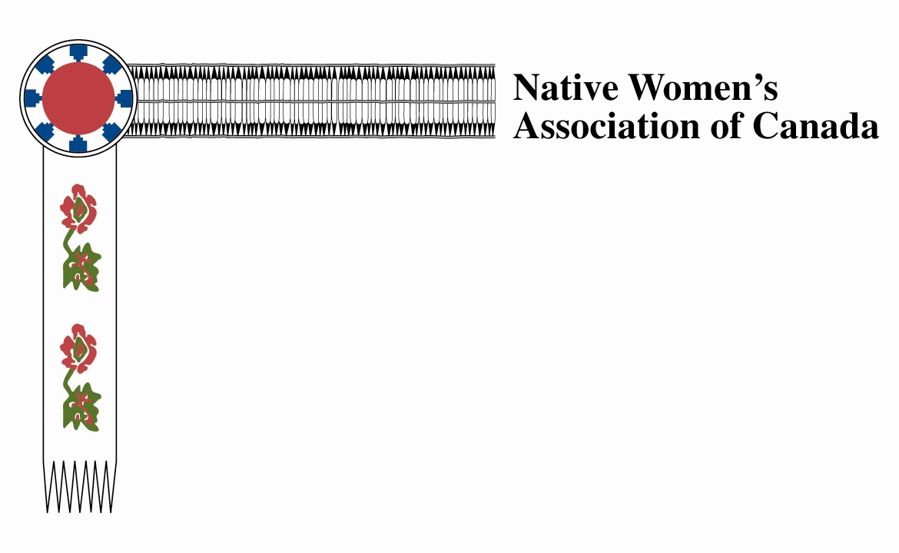

Balancing the Scales of Justice: Bill C-262’s implementation of UNDRIP is a necessary step toward reconciliation
NDP MP Romeo Saganash – Abitibi, James Bay, Nunavik, Eeyou – introduced his private member’s bill, Bill C-262, to the House of Commons on April 21, 2016. Bill C-262 is one of the most important Bills before Parliament, and the fate of this proposed legislation will have far-reaching impacts on Canada’s reconciliation efforts.
The Bill, which will require conforming Canada’s legislation with the United Nations Declaration on the Rights of Indigenous Peoples (UNDRIP), is a tall order. Among other things, UNDRIP: C
- Calls for the recognition of the indigenous right to self-governance and the right to withhold consent for state actions that may impact on indigenous rights or interest;
- Prohibits acts of genocide and assimilation;
- Requires the state to take measures to protect Indigenous women and children from violence; and
- Affirms that Indigenous rights are guarantees equally to men and women.
The UNDRIP, therefore, requires Canada to recognize and respect the unique places and circumstances of Indigenous peoples in Canadian society and government.
Free, prior and informed consent is a powerful right that will affect the authority of the state to make decisions that may impact Indigenous peoples. How decisions are to be made in an UNDRIP-conforming governance structure is unclear. Ending the cultural genocide requires extensive legislative amendments and the establishment of many modern treaties. Protecting Indigenous women and children from violence will likely be costly and require systemic changes to state institutions new and old.
Implementing UNDRIP and ensuring that the laws of Canada respect the Declaration will be a long and difficult road, but this is a necessary road on the way to reconciliation. That these processes will at times be painful, adversarial and expensive is no excuse to shy away from the demands of justice and human rights.
Bill C-262 is one step on a long journey toward a better Canadian society – a society in which respect for the sphere of traditional government is on par with federal and provincial spheres. Taking on this défi national requires conviction and strength and it is a challenge that the political leaders in Canada may not have the character to wrestle honestly; however, in the approach to Bill C-262, it is vital that Parliament appreciate the weight of these matters.
Full implementation of UNDRIP will constitute one of the greatest leaps toward reconciliation in Canadian history and significantly address the multitude of mechanisms that marginalize Indigenous peoples and that subject Indigenous women and children to poverty and violence. Denying Indigenous peoples the rights to which they are entitled at international law will perpetuate the marginalization of First Nations, Inuit and Métis peoples in Canada and obstruct the fair allocation of weights on the scales of Canadian justice for generation to come.

